

2025-26
  - September - March

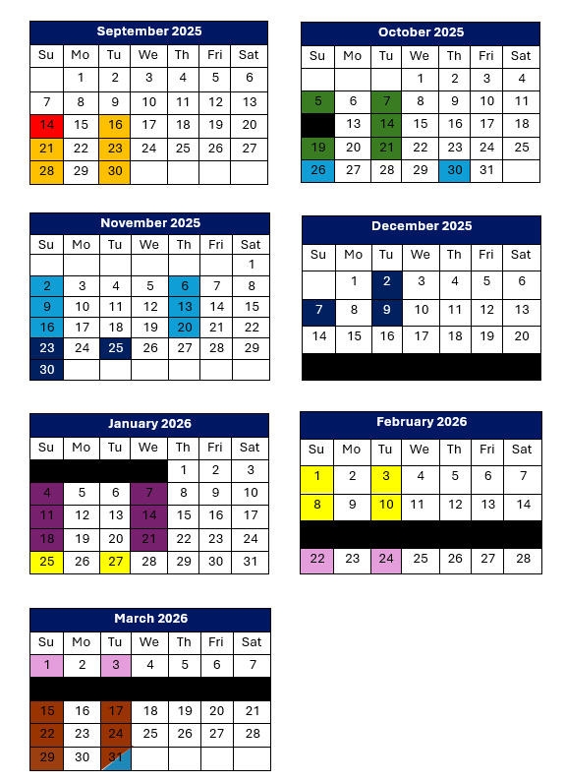

Schedule
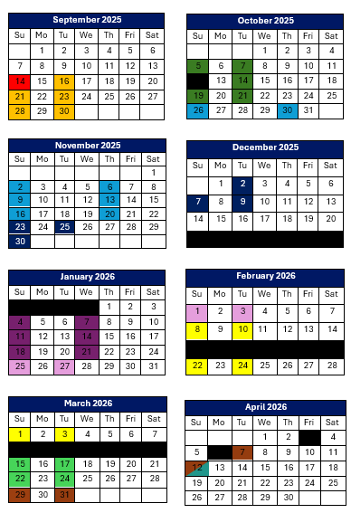
Kick-Off Day
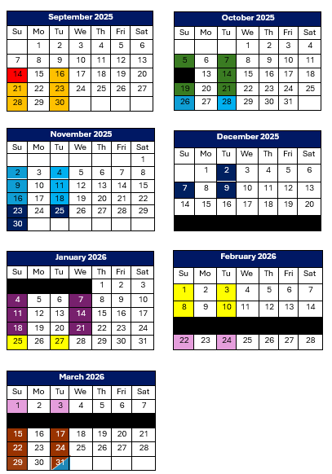
Sun @ Sandlot Field
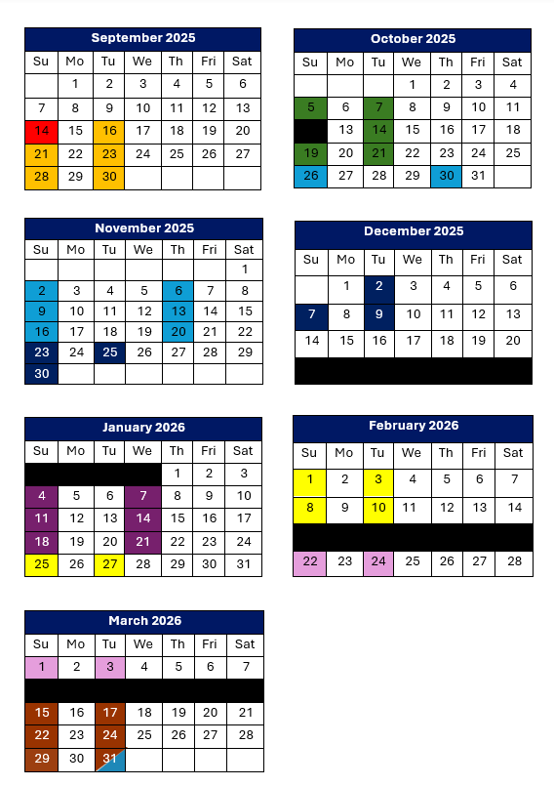
5:00-5:45 PM (Team Blue)
6:00-6:45 PM (Team White)

Baseball/Softball
Tues & Sun @ Sandlot Field
5:00-5:45 PM (Team Blue)
6:00-6:45 PM (Team White)

Taekwondo
Tues & Sun @ SAJS
5:00-5:45 PM (Team Blue)
5:45-6:30 PM (Team White)

Hockey
Sundays @ STFX AUX Rink
4:30-5:15 PM (Team Blue)
5:50 – 6:15 PM (Team White)
Tuesdays @ Town Rink
3:30-4:30 PM (Both Teams)

Athletics
Sun & Tues @ SAJS
5:00-5:45 PM (Team Blue)
6:00-6:45 PM (Team White)

Swimming
Sunday & Wednesday @ STFX
5:00-5:45 PM (Team Blue)
6:00-6:45 PM (Team White)

Gymnastics
Sun & Tues @ STFX AUX GYM
5:00-5:45 PM (Team Blue)
6:00-6:45 PM (Team White)

Basketball
Sun & Tues @ SAJS
5:00-5:45 PM (Team Blue)
6:00-6:45 PM (Team White)

Soccer
Sun & Tues @ SAJS
5:00-5:45 PM (Team Blue)
6:00-6:45 PM (Team White)

Wrap-Up Celebration
CONTACT INFORMATION
antigonishmultisport@gmail.com
902-318-4048
Tuesday March 31 @ SAJS
Final 15 minutes to celebrate with staff!

Holidays/Breaks

